

MYLASSA MAUSOLEUM PROJECT

by

122202022 Hamza Yiğit ÜNSAL
122202082 Mustafa Taha AKOĞLU
123202096 İbrahim Çağlar YILDIRIM

Supervised
by

Prof. Ahmet DENKER

Asst. Prof. Mert MENGİLLİ

Dec 30th, 2024

ACKNOWLEDGMENTS
We would like to express our appreciation to Ahmet DENKER and Mert MENGİLLİ, our professors, for their support and guidance with this effort. They dealt with our questions and maintained us motivated each week in the lab, which greatly affected our development.

We also appreciate the efforts and contributions of İbrahim Çağlar YILDIRIM and Mustafa Taha AKOĞLU, two members of our team. We worked effectively and completed our objectives with the leadership of Hamza Yiğit ÜNSAL, our team captain.

ABSTRACT
This project draws on AutoCAD 2025 to model the Mylassa Mausoleum in both 2D and 3D. The objective was to improve technical and collaborative abilities while creating detailed architectural designs. The distribution of tasks in the 2D part was as follows: Hamza worked on the facade and flank drawings, Mustafa produced details 1 and 2, and İbrahim finished the plan design. İbrahim and Mustafa worked together during the 3D modeling phase, with İbrahim creating the isometric view. Hamza was responsible for rendering the 3D model.

Hamza and Mustafa developed the presentation reports, guaranteeing a thorough overview of the project. Hamza, the team captain, managed the task division. This project offered more than just a chance to use AutoCAD abilities.

TABLE OF CONTENTS
ACKNOWLEDGMENTS ii
ABSTRACT iii
TABLE OF CONTENTS iv
LIST OF TABLES vi
1 INTRODUCTION vi
1.1 Background and Literature Survey 1
1.2 Objectives 2
1.3 Realistic Design Constraints 2
1.4 Approach and Methodology 3
2 RESEARCH AND ORGANIZE 4
3 2D DRAWINGS 5
3.1 Improving Existing Images 5
3.2 2D Drawings 5
3.2.1 Mylassa Plan Drawing 6
3.2.2 Mylassa Detail 1 Drawing 6
3.2.3 Mylassa Detail 2 Drawing 7
3.2.4 Mylassa Facade Drawing 7
3.2.5 Mylassa Flank Drawing 8
3.2.6 Mylassa Isometric Drawing 8
4 3D MODELLING 9
5 SYNTHESIZING 10
6 RENDERS 11
6.1 Introduction 11
6.2 Rendered Images 12
7 CONCLUSIONS 14
7.1 Introduction 14
7.2 Time Table 14
REFERENCES 15

LIST OF FIGURES
Figure 1: Example of improving images 5
Figure 2: Plan drawing 6
Figure 3: Detail 1 drawing 6
Figure 4: Detail 2 drawing 7
Figure 5: Facade drawing 7
Figure 6: Flank drawing 8
Figure 7: Isometric drawing 8
Figure 8: 3D model 9
Figure 9: Synthesization of model 10
Figure 10: Rendered View 1 12
Figure 11: Rendered View 2 12
Figure 12: Rendered view 3 13
Figure 13: Rendered view 4 13

LIST OF TABLES
Table 1: Time table 14

INTRODUCTION

Background and Literature Survey
This project was specifically conducted to create a 2D and 3D modeling of the Mausoleum of Milas and used with AutoCAD 2025, which is one of the most popular software for building architectural and engineering designs. The Mylassa Mausoleum (TUR: Gümüşkesen Anıtı) is located in a historical town of Milas and serves as an important archaeological symbol of ancient Carian architecture.

The most important goal of the current project is to create a digital representation of the monument with complete attention and attention about historical and architectural details. Advanced tools within AutoCAD 2025 will be used for accurate drawing of the mausoleum along with demonstration of technical and teamwork skills.

This project serves as a motivation from previous studies with focus on the use of digital reconstructions in the preservation of monuments. Other similar implementations have already shown the benefits of 3D models in education, restoration, and tourism. The combination of digital tools with architectural preservation guarantees that such monuments can be enjoyed by future generations and at the same time be subjected to detailed analysis and documentation.

The review literature in this section also discusses CAD-effected contributions to architectural modeling and digital reconstructions of ancient structures. Such studies demonstrate the bridging roles CAD software has between history and technology. In tandem with the integration of reports, compiled 2D and 3D models, further highlight the importance of such projects in academia and otherwise.

Objectives
The main purpose of this project is based on making detailed 2D and 3D digital models of the Milas Mausoleum by using AutoCAD 2025. The essential architectural features of the mausoleum will be correctly modeled; attention will be paid to structural details and historical depiction. The name symbolizes the digital bringing back of the monument in terms of what it means historically and culturally while proving himself worthy in nowadays CAD software.
This project, in addition to digital modeling, aims to improve the Milas Mausoleum as part of the rich architectural cultural history of Turkey. The project includes 2D drawings along with a 3D model to support educational areas related to architecture, history, and digital design. This will allow a deeper understanding of the mausoleum's design and, on the other hand, provide important perspectives into the way digital technologies can be applied in preservation and restoration efforts for historical sites.
It aims to create an all-inclusive as well as an easily available digital representation of the Milas Mausoleum for future studies and to be an exciting educational tool for both academic and public readers in future.

Realistic Design Constraints
The project aims to replicate the Milas Mausoleum digitally with a significantly higher degree of historical accuracy through AutoCAD 2025 software. The main model of the mausoleum is matched and showed the original structure. In fact, it was the result of detailed research and available records that ensured that an architectural feature was represented faithfully.

AutoCAD 2025 provided the equipment with which the mausoleum could be correctly modeled as changes for both detail and manageability were possible. Thus, full attention was given to the critical architectural elements while fully ensuring that the dimensions and proportions of the structure were accurately represented.
The long duration of the project allowed for a successful approach that considered significant elements of the mausoleum in producing a complete digital rendering.

Approach and Methodology
The aim of the project digital replication of the Milas Mausoleum through AutoCAD 2025. The approach was very acceptable considering the resource of the project. Since mausoleum is a historical monument, 2D drawings have been made for the facade, the flank, Detail 1, Detail 2 and plan parts. Theese made the project more realistic.
The next step, having prepared the 2D drawings, was that of 3D modeling. Therefore, translating 2D into 3D by emphasis on some principal structures of the mausoleum: columns, walls, roof by an application of AutoCAD 2025, becomes the next step. This phase becomes important because it provided an option of seeing the mausoleum in three dimensions and being certain that proportions and details matched as closely as possible to the original historical design.
We encountered some challenges during the 3D modeling phase because we had many sources for detailed representations of the mausoleum, but showing small details needed more attention and care. Thus, in modeling, we worked on correctly modeling the main architectural features based on existing materials and 2D drawings; it would result in exact but manageable modeling, supporting the progress of the project during available time and resources.
Based on the completion of the mausoleum 3D model, isometric view were created. The 3D model was then rendered into more realistic visibility representations after the completion of the isometric view. These representations shows how the mausoleum would have looked today. This is very helpful in understanding the model and gaining a feel for what the mausoleum actual architecture would be like.
Overall, the approach has been taken that historical certainly would guide us and ensure a structured modeling process. The 2D drawings have been good enough for making the 3D model. We did some adjustments in the modeling phase to bring the final digital model in match with how it should look in terms of its original creation.

RESEARCH AND ORGANIZE
The first stage in developing our project is the organization of the required resources and planning of the workflow. As the project is about replicating an ancient structure, developing meaningful materials was the first step involved in thoroughly understanding the input. These resources included 2D drawings of the mausoleum’s important parts-the facade, flank, and so essential for the modeling process.

The next phase is systematically organizing the resources and defining the workflow. This was a way of ensuring understanding and efficiency throughout the development process. We set a reasonable plan about how we would be transforming the 2D drawings into a 3D model.

At the end, the assignment of role was in line with the needs of the project to improve time and energy efficiency. Such early organization became the foundation for a easy development process and accuracy throughout the project.

2D DRAWINGS

Improving Existing Images
First of all, the images provided to us were not suitable for use as reference bases for direct 2D drawings due to reasons such as perspective errors. Due to errors, we might not be able to properly align the 2D reference drawings when we did 3D modeling. Therefore, some corrections were applied to the photos using GIMP image editing software. For example:

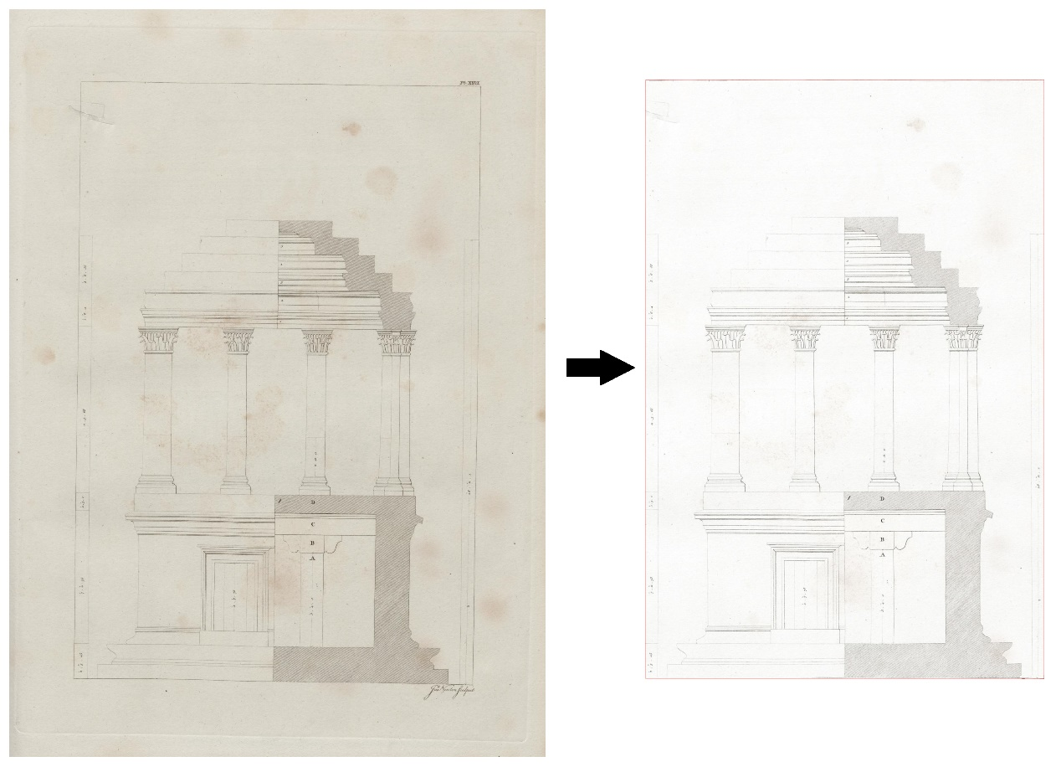
Figure 1: Example of improving images

2D Drawings
Continues from next page…

Mylassa Plan Drawing
This drawing was made by our team member İbrahim Çağlar YILDIRIM.
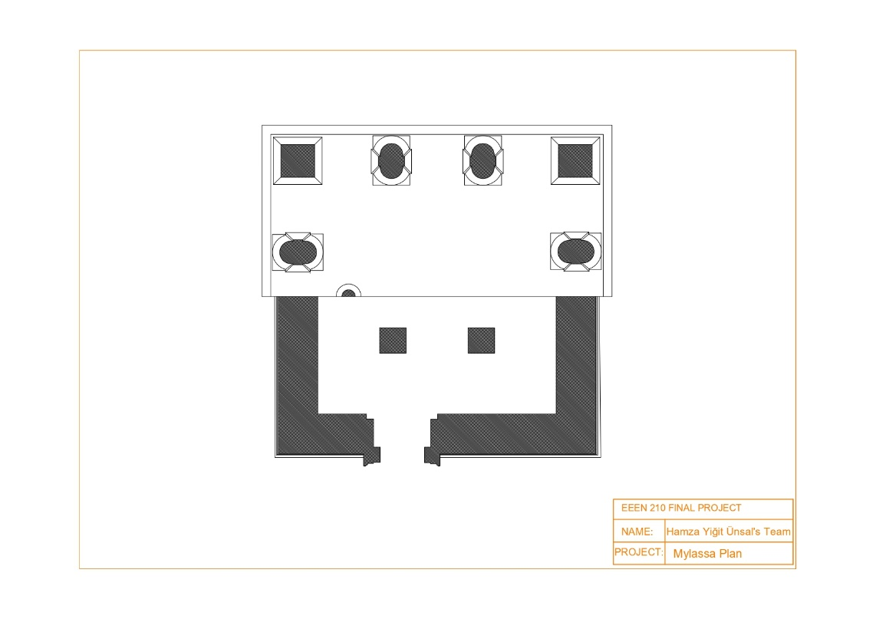
Figure 2: Plan drawing

Mylassa Detail 1 Drawing
This drawing was made by our team member Mustafa Taha AKOĞLU.
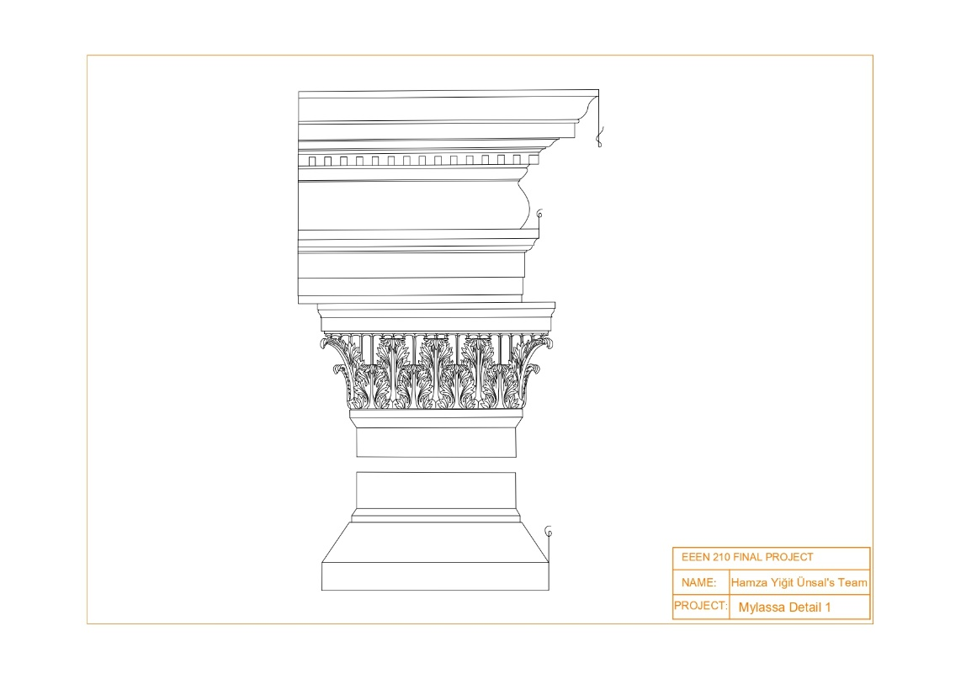
Figure 3: Detail 1 drawing

Mylassa Detail 2 Drawing
This drawing was made by our team member Mustaf a Taha AKOĞLU.
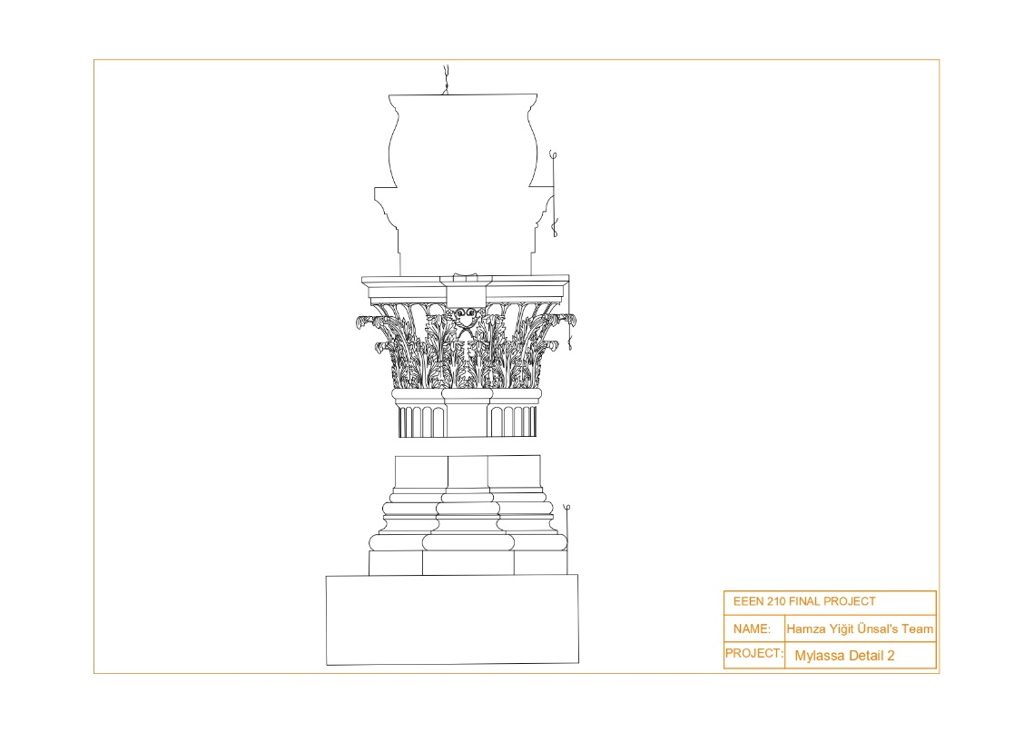
Figure 4: Detail 2 drawing

Mylassa Facade Drawing
This drawing was made by our team member Hamza Yiğit ÜNSAL.
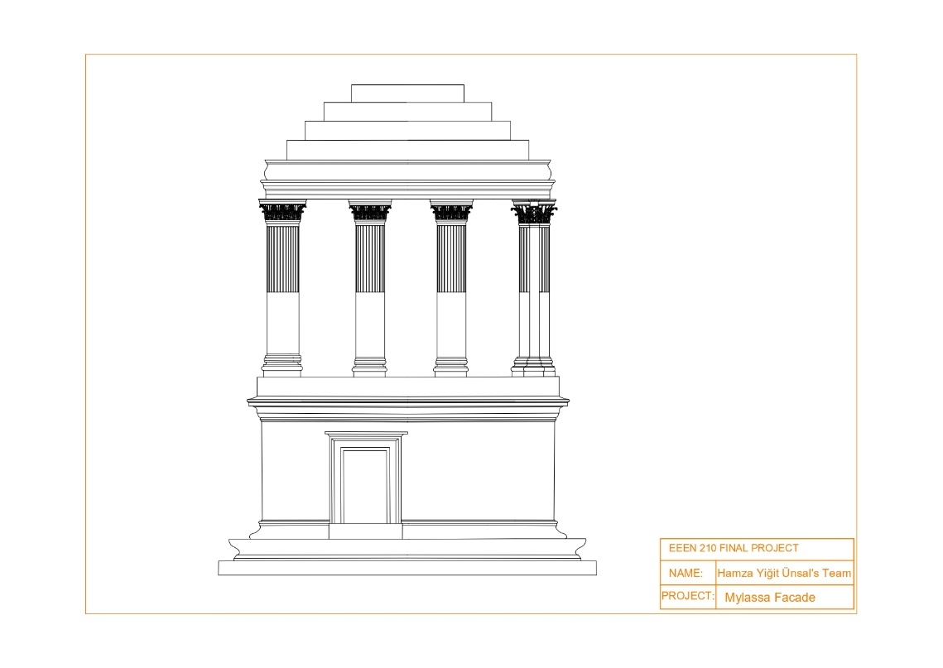
Figure 5: Facade drawing

Mylassa Flank Drawing
This drawing was made by our team member Hamza Yiğit ÜNSAL.
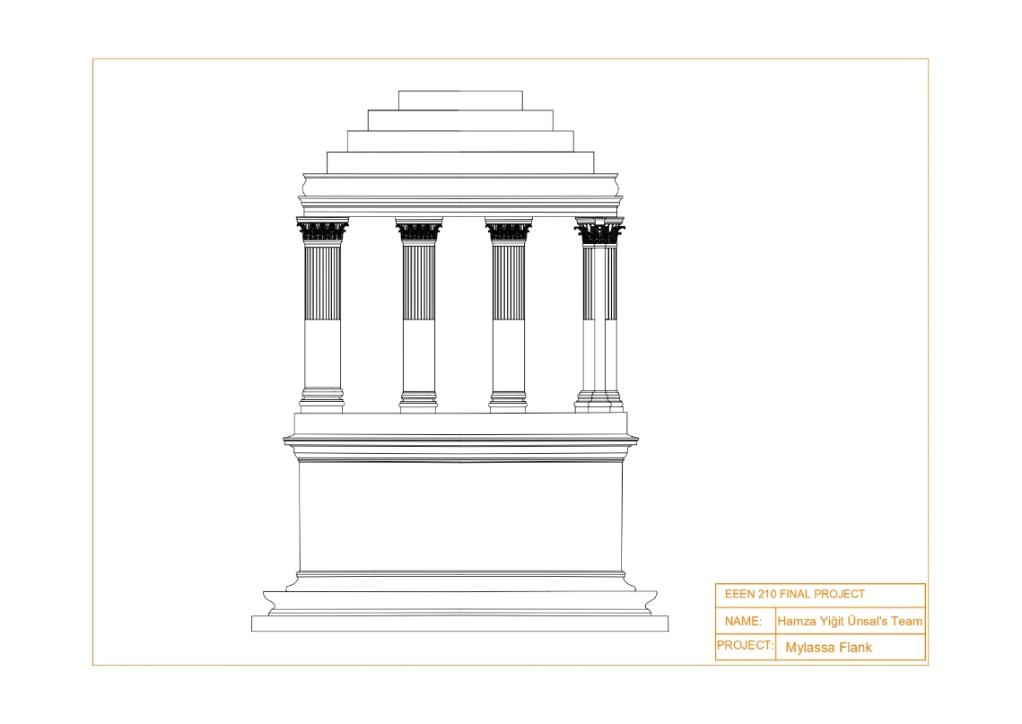
Figure 6: Flank drawing

Mylassa Isometric Drawing
This drawing was made by our team member İbrahim Çağlar YILDIRIM.
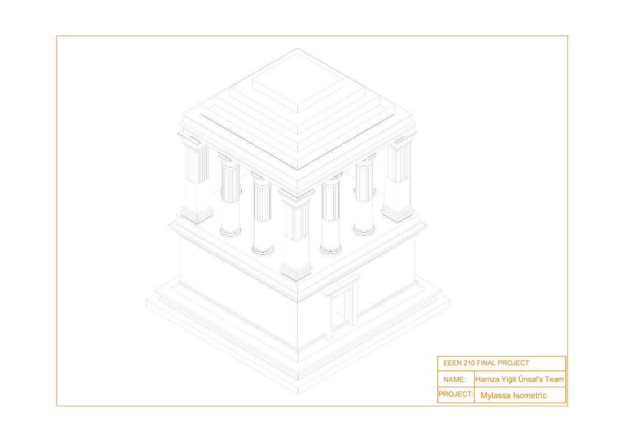
Figure 7: Isometric drawing

3D MODELLING
3D model were made by Mustafa Taha AKOĞLU and İbrahim Çağlar YILDIRIM.

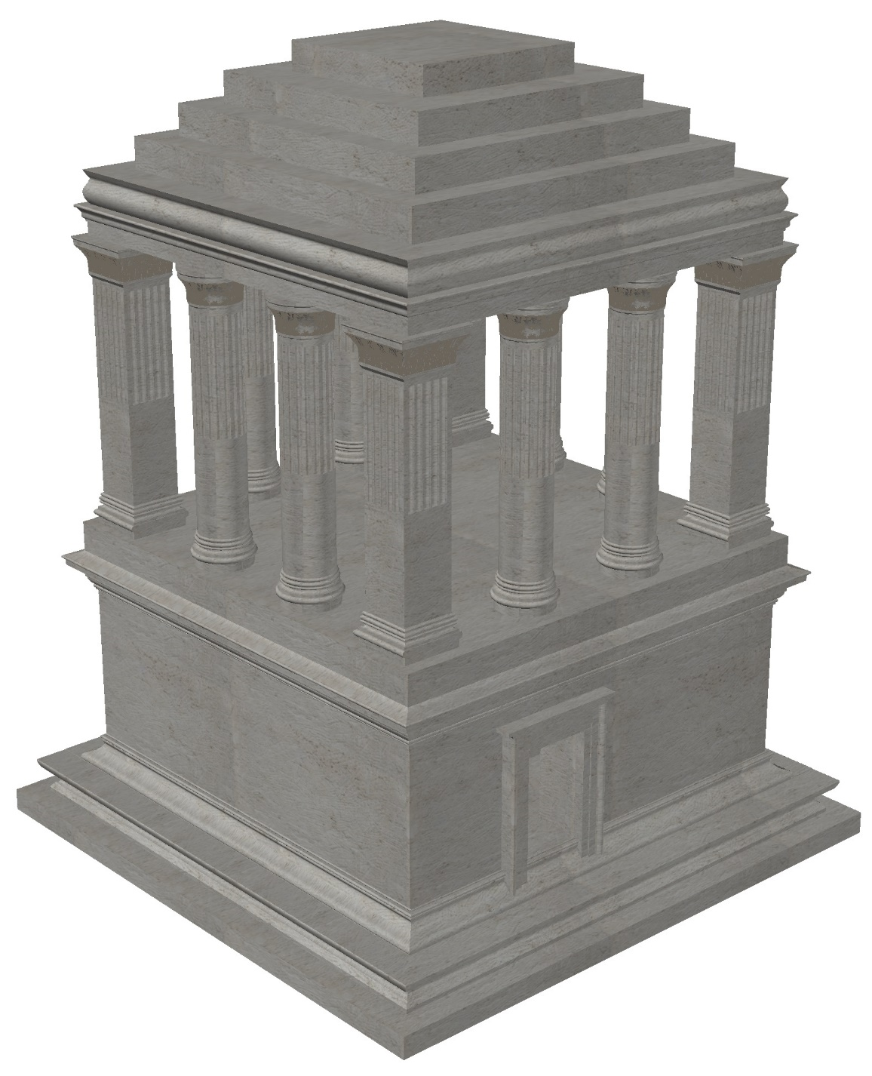
Figure 8: 3D model

SYNTHESIZING
This chapter explains how we combined the work done in the 2D and 3D modeling stages of the project. The goal was to bring all the parts together and create a clear and complete representation of the Mylassa Mausoleum.
The 2D drawings were the first step in the process. Each part of the monument, like the facade, flank, and details, was carefully drawn. These drawings helped us understand the structure and plan the next steps.
In the 3D modeling phase, we used the 2D drawings to create a three-dimensional view of the monument. We used AutoCAD tools to model these parts accurately. Firstly, we properly aligned the 2D drawings. After that, we used these drawings as references for 3D model. Teamwork was very important in this phase, as each member worked on specific tasks to save time and improve the results.
Finally, the 2D and 3D models were combined to show the full design of the Mylassa Mausoleum. These models help us see the historical and architectural importance of the monument. This project taught us how to work as a team and use digital tools effectively to create accurate and detailed models.
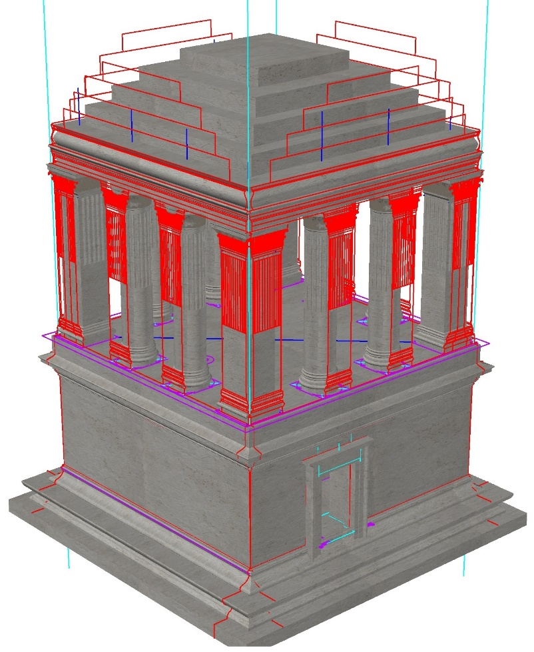
Figure 9: Synthesization of model

RENDERS

Introduction
Render outputs were made by İbrahim Çağlar YILDIRIM and Hamza Yiğit Ünsal. We added some minor environmental details and sloping terrain to get a nice pose. Terrain model obtained from Bing Maps through SketchUp’s Geolocation add-on. After that, terrain’s and mausoleum’s location and perspective geolocated for achieving true sunlight angles according to location, date and time for realistic illumination.

Rendered Images
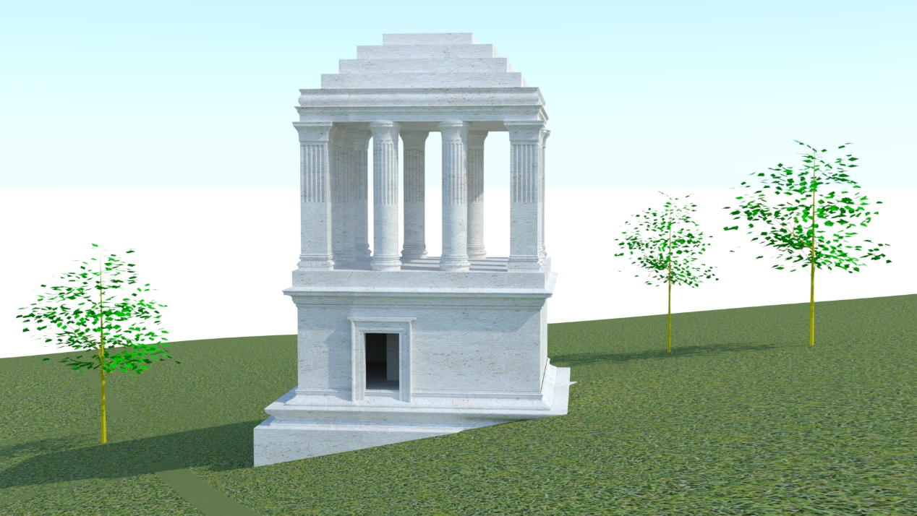
Figure 10: Rendered View 1

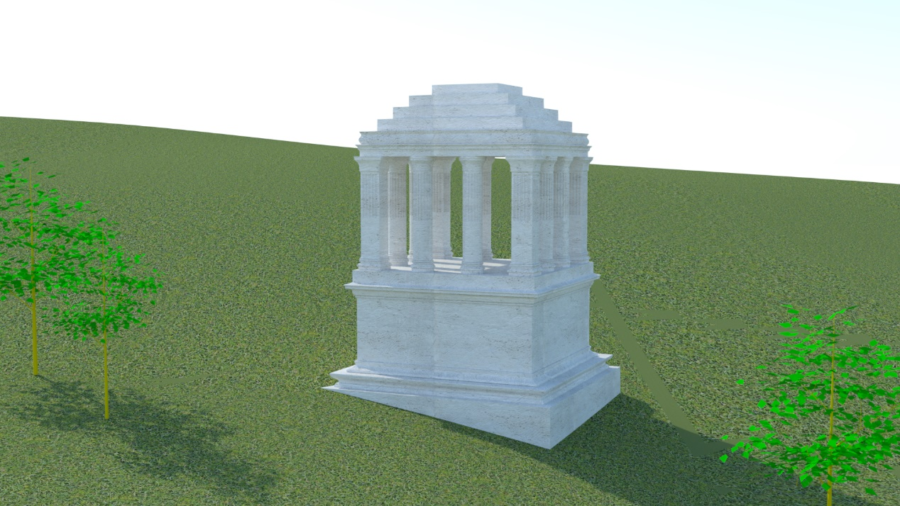
Figure 11: Rendered View 2
Continues from next page…

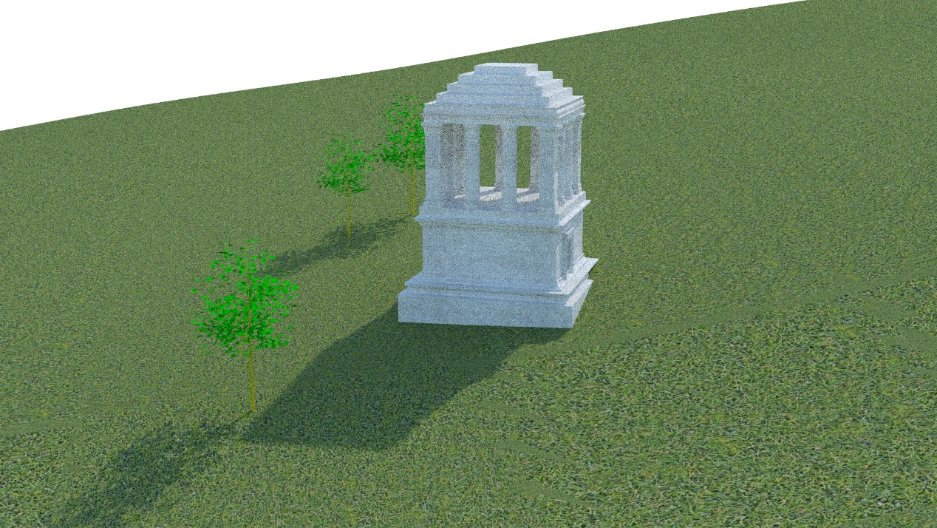
Figure 12: Rendered view 3

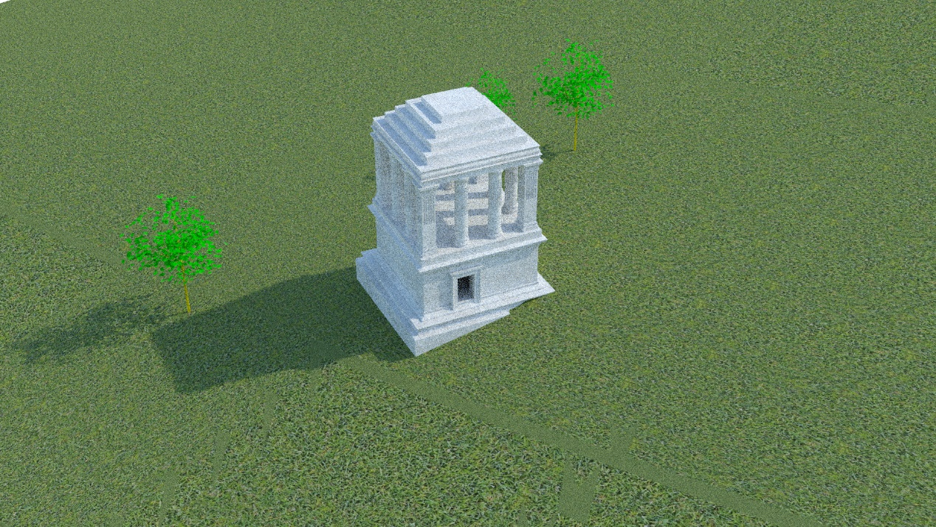
Figure 13: Rendered view 4

CONCLUSIONS

Introduction
First, we as a team met and divided the task. In addition to that, there was a well-defined step-by-step plan which was going to be followed throughout the project. We started the creation of drawings in the early stage, and we've worked on 2D: plan, detail 1, detail 2, facade, flank for all the generated outputs to work on. There has been a method above studying the best way to create a 3D representation of this historical structure with all its important architectural properties. 3D was finally completed. The 3D model was used in preparation of the isometric drawing, which gives an obvious perspective of the structure. After it was completed, we added in the sky and sunlight visual that made the 3D object looked more realistic and then we rendered it.
This project not only taught us how to digitally recreate a historical structure but also helped us understand the importance of teamwork and organization. By dividing tasks among team members and cooperating, we were able to complete the project more efficiently.

Time Table
Task | Completion Date
Completion of Detail 1 and Detail 2 DWGs | Sunday, 08 December 2024
Completion Facade and Flank DWGs | Wednesday, 11 December 2024
Completion of Plan DWG | Thursday, 12 December 2024
Completion of 3D Modeling | Sunday, 22 December 2024
Completion of Rendering | Tuesday, 24 December 2024
Completion of Presentation and Report | Sunday, 29 December 2024
Table 1: Time table

REFERENCES

- Society of Dilettanti [Editor]: Antiquities of Ionia (Band 2) (London, 1797). (n.d.-b). https://digi.ub.uni-heidelberg.de/diglit/dilettanti1797bd2/0065/image,info
- Society of Dilettanti [Editor]: Antiquities of Ionia (Band 2) (London, 1797). (n.d.). https://digi.ub.uni-heidelberg.de/diglit/dilettanti1797bd2/0066/image,info
- Society of Dilettanti [Editor]: Antiquities of Ionia (Band 2) (London, 1797). (n.d.-c). https://digi.ub.uni-heidelberg.de/diglit/dilettanti1797bd2/0067/image,info
- Society of Dilettanti [Editor]: Antiquities of Ionia (Band 2) (London, 1797). (n.d.-d). https://digi.ub.uni-heidelberg.de/diglit/dilettanti1797bd2/0069/image,info

